 |  | Bath Community School / January Edition
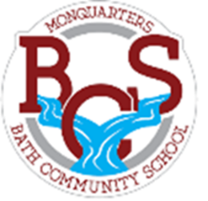
Monquarter Memo
Phone: 278-6000 Twitter: @BathMonquarters
Website: http://BCS.nbed.nb.ca/
Upcoming: Character Strong
Visit the Portage Atlantic Facebook page (@PortageAtlantic) to find the information and links to register.  Or, if viewing our newsletter elecronically, you may use the following links:  To register for MONDAY CLICK HERE  To register for WEDNESDAY CLICK HERE  Reminders  Things students need every day:  - at least two clean masks  - a clean water bottle  - warm, dry clothes for outdoor recess and/or Phys. Ed. |  |  |  |  | Children are faced with many opportunities and challenges as they enter a fast-changing world, and we want to do everything we can to encourage and empower their success.  We are excited to share that we will be using a program called Character Strong this year. It is all about helping schools weave simple, powerful, relatable content into everything happening at school and beyond!  It includes lessons and activities to help teach a wide variety of traits that we know help make students more successful in their academics and in their lives outside of school.
PERSEVERANCE
Try this activity at home!

